**CLAP SWITCH**

In order to make a [clap switch](http://www.buildcircuit.com/tag/clap-switch-kit/), we have to combine the  [touch sensor(monostable mode of 555](http://www.buildcircuit.com/modes-of-ne555-monostable-and-astable/) and the transistorized dark sensor circuits. Whenever there is loud sound produced near the electret condenser mic, pin 2 of 555 gets triggered and it switches on the LED D1. The LED remains on for a definite time determined by R1 and C1. We can adjust the sensitivity of the circuit using a variable resistor in place of fixed resistor R5. You can check the circuit with 1K or 10K.

**The schematic of clap switch:**

[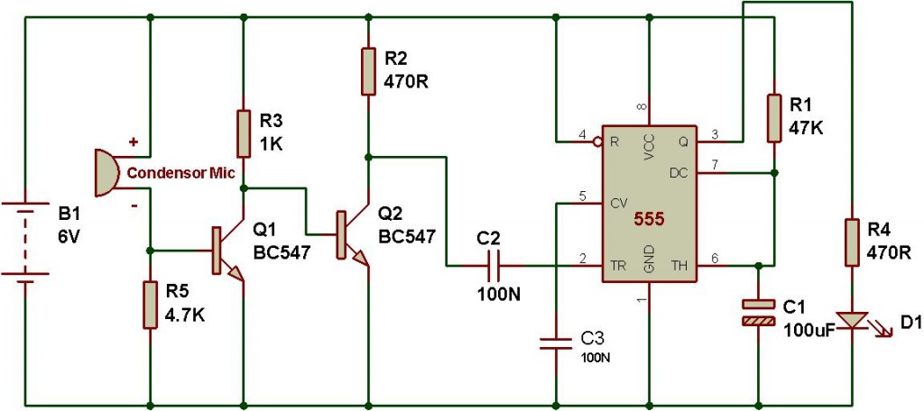](http://www.buildcircuit.com/wp-content/uploads/2010/11/clap-switch.jpg)

**COMPONENT USED**

1-Condenser mic

2-Resistors-: 1K; 470R;47K;4.7.

3-Capacitor-: 0.1UF;100UF.

4-555 TIMER IC

5-transistor-bc547

6-9 V0lt battery